Final Project Design Phase
Computer Science - Week 11
Oct 3, 2026 - Version 0.0.4

For complete instructions and project ideas, refer to the assignment in Canvas. Specifically, review the final project requirements before you continue below. If you have not reviewed the project requirements in Canvas (you might have to go to the modules view and check the current or past week's content), you will not be able to properly complete the parts below. In addition, it may be helpful to review the information on this Drafter documentation page.

0) Project Planning and Preparation
Successful programmers spend time planning before they begin coding. After reviewing the project requirements, answer the following questions to help guide your design and development process.
- What concepts from class or previous assignments might help you complete this project? Which programming concepts (loops, conditionals, lists, classes, etc.) do you expect to use? What programming skills do you want to improve while completing this project?
My project will rely heavily on iterating lists and instances of dataclass using for loops. I expect to write this type of program more proficiently, as well as the ability to use comments and docstrings to communicate the purpose of the code efficiently.

- Which parts of the project do you expect to be the easiest for you? The hardest? Why?
The easiest part will probably be designing the user interface of the website, as it is just returning different Pages. The hardest part will probably be ensuring the types of the different variables are correct, as all user inputs are strings, and one tiny error could mess up the entire code.

- Even though you have not yet designed the final project, estimate which tasks will likely require the most time and effort? Which features or components should be implemented first?
The most time and effort would probably be used to build the actual calculation part of my code, because there are many unit conversions, and different scenarios.

- What distractions might interfere with your work and how will you minimize them? What resources will you need available while working? What questions, if any, do you still have about the assignment requirements?
Other course works might be interfering with my work in the final project. I will minimize those distractions by managing my time better. When I have questions, I will use the discord channel or a LLM to help me identify the problem, but I will try my best to solve it myself.

1) Site Diagram
Create a mock-up of your planned website. We suggest you make the mockup on paper, although you can also use software like PowerPoint or Slides to make a mockup. There is other design software that could also be used, but we strongly encourage you to keep it simple. Do not spend more than 15-30 minutes detailing the mock-up. Your goal should be to make a very quick and dirty diagram, to show that you have some kind of idea.

We recommend drawing each page as a rectangle, and laying out the text, buttons, and other components inside. Then, use arrows to indicate links between pages. Label each page the way you will name each function, and then put labels on the arrows to indicate what the button links. Also write down any parameters that should come into the pages.

In addition to the pages and routes, write down what fields your `State` will have, both their names and types. Think clearly about what data will need to be persistent across the entire website.

Add photo(s) or screenshot(s) of your website mock-up and labeled diagram on the next page.

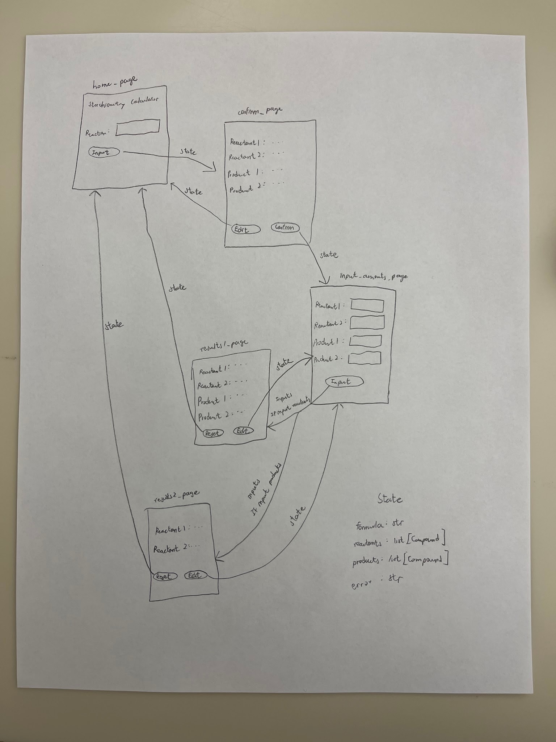
2) Implementing Requirements
This table should serve as a draft for how you will implement the requirements into your final project. You may change your ideas later on, but your final site must fulfill all the requirements.

Requirement | Implementation
Purpose/Functionality  A 1-2 sentence description of the purpose or functionality of your site | The purpose of my site is to do stoichiometry calculations of chemical reactions automatically, so the user won’t have to waste time doing those calculations by hand. This improves both efficiency and accuracy.
State Dataclass Attributes  Minimum of 4 attributes, one of which must be a list/dict of instances of your second dataclass.  Briefly describe each attribute, its type, and how it will be meaningfully modified throughout the site. | formula(str): the formula of the chemical reaction input by user, it will be modified once there is a new chemical reaction input  reactants(list[Compound]): the reactants of the reaction, modified in almost every step of the program  products(list[Compound]): the products of the reaction, modified in almost every step of the program  error(str): allows an error message to be displayed, modified when an error is identified and needs to be displayed to the user
Second Dataclass  Your second dataclass, including its attributes, their types, and how they will be meaningfully modified (if they are modified) | class Compound  formula(str): the chemical formula of the compound, modified when a new reaction is input  molar(float): the molecular weight of the compound, value from the molmass library  coefficient(int): the coefficient of the compound in the reaction formula, modified when new reaction is input  initial(float): the starting amount of the compound in the reaction, in grams, modified once user inputs the starting values  final(float): the ending amount of the compound in the reaction, in grams, modified when running calculations
Routes (minimum 7)  The names of your route functions | index  input_formula  edit_formula  confirm_formula  input_amounts  edit_amounts  reset_all
Pages (minimum 5)  A brief description of the pages in your site | Home page: includes the name of the site, allows user to input a chemical reaction  Reaction Confirmation page: shows the reactants and products of the reaction, allows user to confirm or edit  Amounts input page: allows user to input the starting values for the stoichiometry calculations  Results page 1: when user input values of reactants, this page shows theoretical yield of products and remaining reactants if any, and also provides buttons to edit the amounts or reset to home page  Results page 2: when user input values of products, this page shows the reactants needed, and also provides buttons to edit the amounts or reset to home page
User Input (minimum 3)  Description of user input components (TextBox, TextArea, CheckBox, or SelectBox) and their purposes  For more information on these input types, see Drafter Documentation. | Textbox to input chemical reaction  Buttons to choose to confirm or reject the reaction  Textbox to input starting values for the calculation  Buttons to reset or edit values
If Statements (minimum 3)  Brief description of what will be evaluated in your if statements and how they will meaningfully change the logic of the site | Reject inputs that do not have the correct format  Identify empty inputs  Inside a loop to identify a specific character to separate reactants and products
Loop (minimum 1)  This loop must iterate over the list/dict of dataclass instances in your State attribute.  Description of this loop and why it is meaningful to the site | Modify the reactants and products lists in the state dataclass.

LLM Conversation
If you used an LLM in any part of this work, copy and paste every part of that conversation below. Otherwise, you may be given a zero for the assignment. Obviously, these words will not all be yours, and this is the exception to the requirement at the top of this assignment that all responses be in your own words. If you did not use an LLM to assist you in this assignment, simply say so below.
I did not use an LLM in this assignment.

Final Submission
When you are finished, download this file as a Word Document (docx) and upload the file to the appropriate assignment on Canvas.

